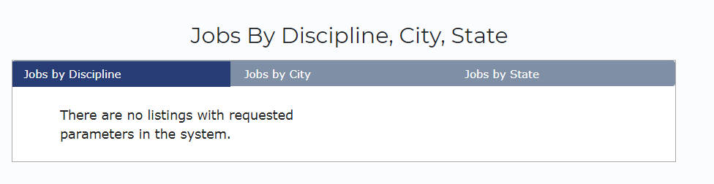

This job category was right from the update version and properly display category .You some changes ??